TRELLO LAB

**Assignment Schedule**

# Objective

To use Trello, a cloud-based task management tool, for planning, assigning, and tracking assignments collaboratively with friends.

# Theory

Trello is a visual project management tool based on the Kanban method. It uses:

* + Boards to represent projects
  + Lists to show stages of progress
  + Cards to represent tasks
  + Members, labels, due dates, and checklists to track and organize work

Trello improves task visibility, collaboration, and accountability, especially for small team-based academic projects.

# Tools and Requirements

* + Trello Account ([https://trello.com](https://trello.com/))
  + Internet access
  + Team members (groupmates)
  + Web browser or mobile app

# Procedure

Step 1: Create a Trello Board

* Open Trello and click on “Create Board”

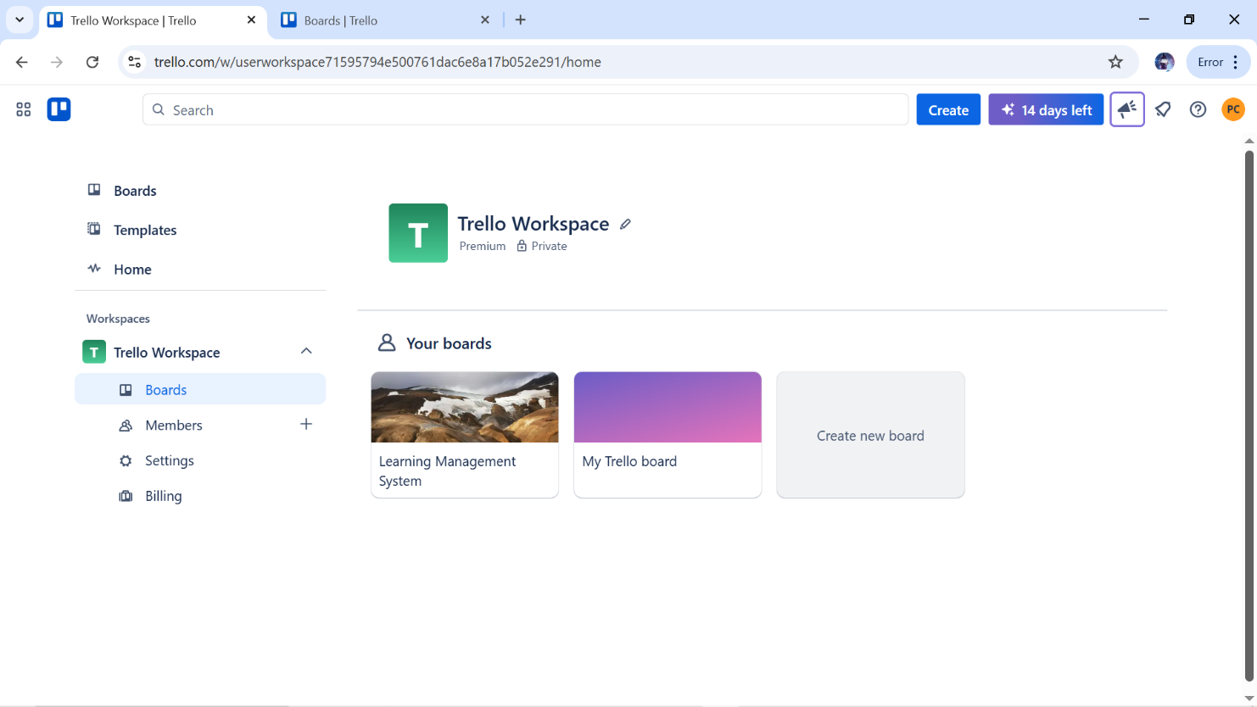

Name it anything you like. ex: *“Learning management system Site Development”*

Step 2: Create Lists to Reflect Workflow

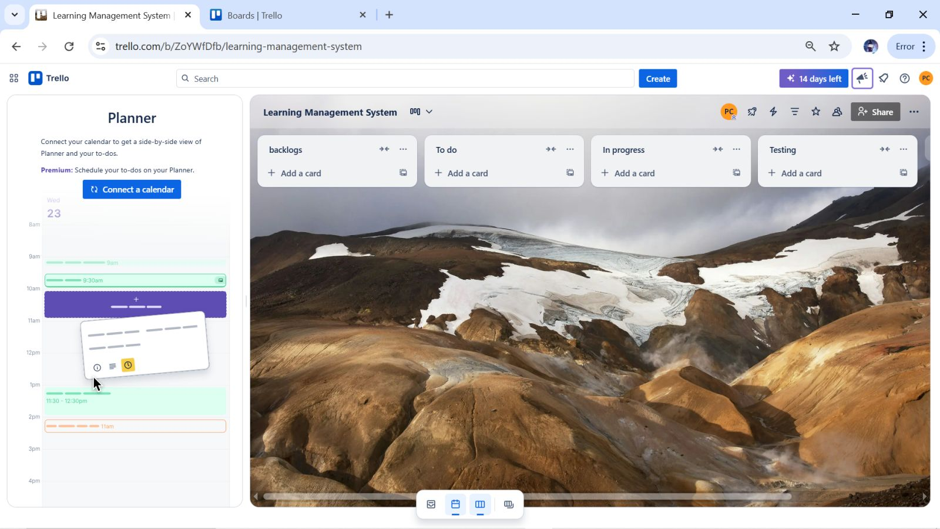

Created lists: Backlog, To Do and In Progress, Testing, Done. These represent the workflow

Step 3: Add cards to your Backlog Idea and To Do . Once the Task on To Do card are in phase of developing move the task to In Progress similarly once task is completed move it to done.

* Create cards as per the requirement. As shown in the figure below:

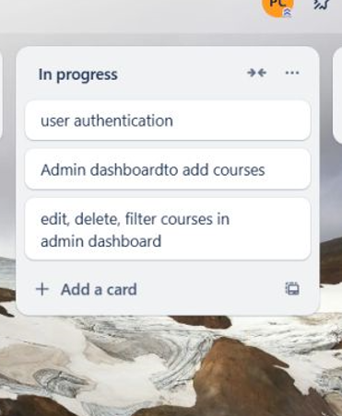

* Each card represents one task

Step 4: Invite Members to the Board

* Used the “Share” button to invite friends

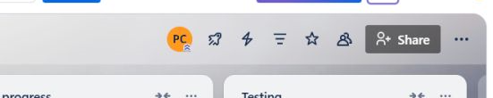

* Enter the name or email of the member, To add them to the board.

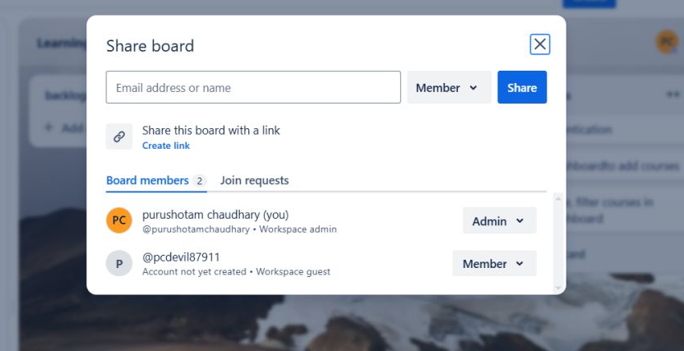

All members can now view and update the board according to their requirements

Step 5: Assign Members to Tasks

* Open each card and assigned responsible members using the “Members” button

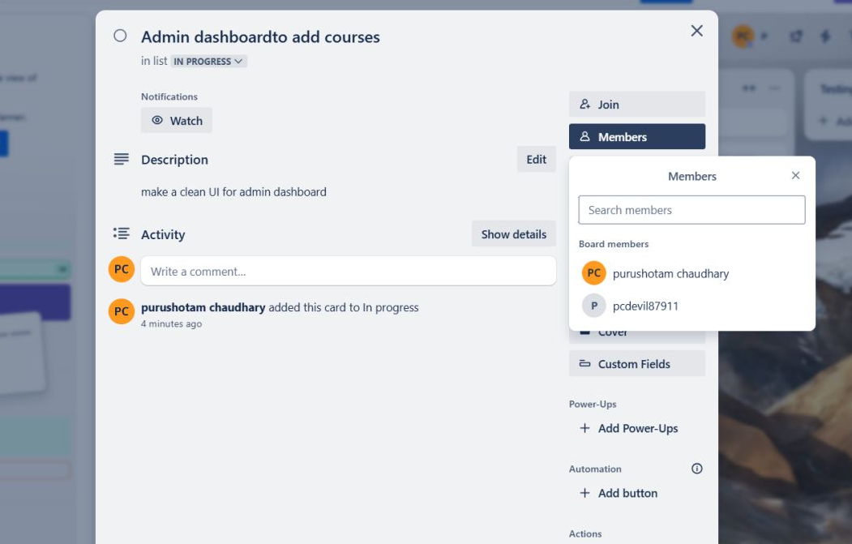

Step 6: Add Due Dates

* Used the “Due Date” feature to set submission deadlines for each assignment. Set starting date and due date.

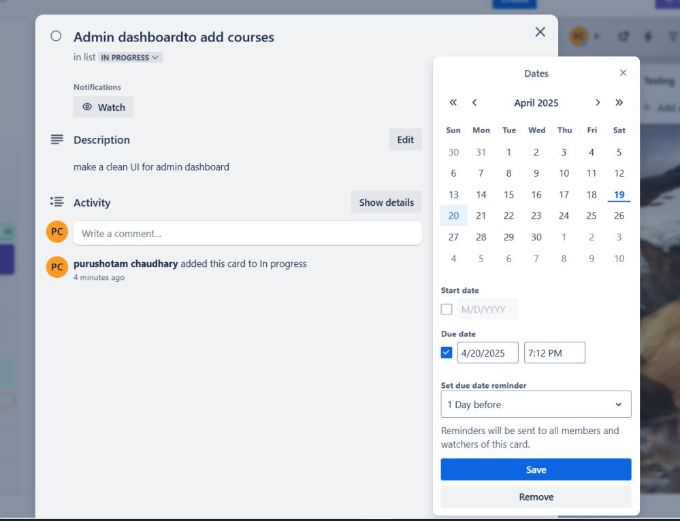

Step 7: Use Labels to Identify Subjects, For this Click on Menu -> Labels .

* Created color-coded labels:
  + Orange → Urgent
  + Brown → Backend
  + Blue → api integration

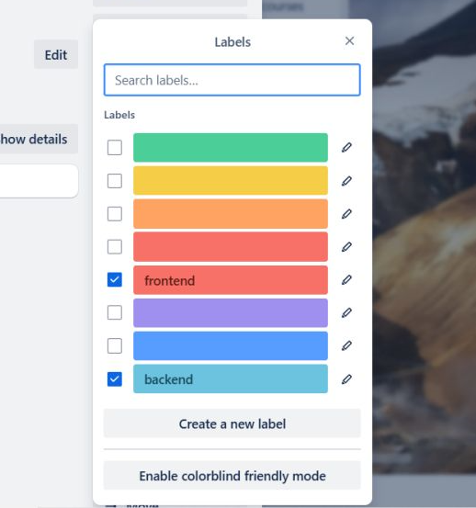

Step 8: Add Checklists

* Checklists in each card will break the task into smaller parts.

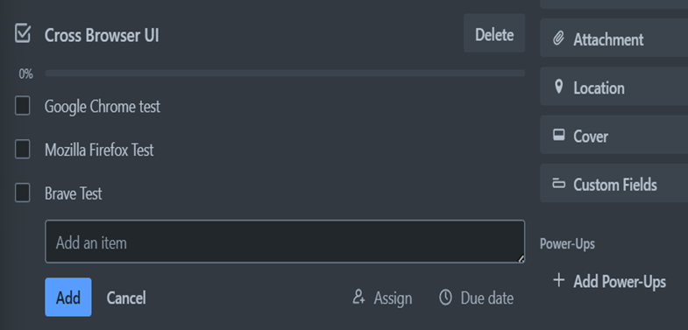

Step 9: Comment and Collaborate

* The comment section is used to update status, ask questions, or share ideas.

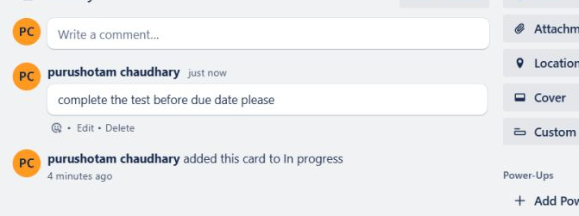

# 6. Conclusion

Trello simplified our team’s assignment management by providing a clear visual layout, easy collaboration tools, and reminder features. It helped us distribute work fairly, track progress, and meet deadlines effectively.